Recorded by: Liming Pals
Date:April 19th, 2023
Approved by:
Date of Approval:

CLD Leadership Council April 2023 Meeting
Minutes of the Meeting

2023 April Meeting Agenda

Time: 9:00 pm -- 10:30 pm EDT, Wednesday, April 19, 2023
Zoom:
Join Zoom Meeting
https://us06web.zoom.us/j/89868843850?pwd=NzlacEcyY0ZqZUc1ZEpYZzYxTHA5UT09
Meeting ID: 898 6884 3850
Passcode: 567717

- Approve minutes from the previous LC meeting 5 min LC
- Introduce volunteers 5 min Tianlu

Tianlu Redmon  贾天璐 | Administrator; ATA communication, events team volunteer | tianlu@tianluchinese.com
Liming Pals  王丽明 | Assistant Administrator; ATA communication, social media team leader | limingpals@gmail.com
Shaoli Gu  古韶莉 | Webmaster, website editor | shaoligu@gmail.com
Fang Sheng  盛方 | Yifeng Editor-in-Chief, website editor | shengf@hotmail.com
Jessie Liu | The CLD Podcast host | jessieliu28@yahoo.com
Rony Gao  高嵘 | Events team leader, website editor | rony.gao@gmail.com
Tingting Qin | Social media team volunteer, events team volunteer | tq@tingbridge.com
Sijin Xian  先思瑾 | Social media team volunteer | projects@xiansijin.com
Additional volunteers | Social media: Yijia “Sasha” Ding, Mingshu Zhang  Yifeng: Ben Murphy, Barbara Hong Li  Ad hoc: Zhenhuan “Duoduo” Lei, Roanna Cheung 张若荇, Jessie Doherty 祝轶君(zhuzhu930@yahoo.com), Tina Teng 鄧欣亞 (hsinya.teng@gmail.com) | Jessie Doherty 祝轶君: volunteer for website maintenance/editing

Teams’ update on:

Team/Item | Number of Minutes | Speaker
Yifeng | 10 | Fang
CLD events | 10 | Rony
The CLD Podcast | 10 | Jessie
Website | 10 | Shaoli
Social media | 15 | Liming & Tianlu
ATA64 proposals, CLD welcoming message, and ATA Quarterly Leadership Summit | 15 | Tianlu
Feedback from attendees | 15 | Attendees
Other matters/agenda proposals & schedule for next LC meeting | 5 | LC

TOTAL: 90 min

Minutes:

Topic | Summary of discussion | Conclusion
- Approve minutes from the previous LC meeting | - Fang Sheng made a motion and Sijin seconded the motion to approve the previous minute.
- Welcome volunteers | - Intro and Welcome Roanna Cheung, Tina Teng, Jessie Doherty as volunteers and observers of LC meeting
- Yifeng Blog | - More articles have been recruited by the team.  - Plan to expand the categories of Yifeng Blog. Would like to encourage emerging translators and interpreters to write and share.  - Current categories include Annual Conference, Certification, Technology and so on. Would like to use learning instead of translation and interpretation.  - Two articles shall be put under Certification. Tianlu would like to suggest adding these to Resources too, and webinar can also be added to resources  - Sijin seconded the above suggestion as new members joined CLD since they saw ATA certification ads. | - Fang will expand current categories.  - Shaoli will add a tab on the website to include resources for ATA certification exams.  - Sijin will promote Rony’s previous article on How to Become Certified in 10 hours and another ATA article.
4. CLD Events | - Four CLD Cafe in first 6 months of 2023:  - 2023-01-17 Enjoy the Show (Sijin Xian) - 19 attended  - 2023-03-18 Ask Me Anything - 17 attended  - 2023-04-01 Digital Note-taking (Eric Liao) - 13 attended  - 2023-05-13 Literary Translation (upcoming)  - On track to meet the target of 8 events in 2023  - Planning for 1 or 2 more events between June and September, in addition to  - CLD Members Meeting (before ATA64)  - ATA64 Debrief  - Year-end Happy Hour around Christmas.  - Tingting encourages everyone to provide ideas and recommend guest speakers.  - Sijin proposes “Translation Slam”. Rony will reach out to Sijin. Tingting mentioned interpretation slam as an option, too. | - Rony will reach out to Sijin and Tingting to discuss further details.
5. CLD Podcast | - Jessie shared a slide. Will add it here.  - Liming shared our Podcast with other sister divisions via listserv and other channels. Three sister divisions agreed to promote our podcast.
6. Website | - Shaoli added a technology category.  - Fang will add a category under Yifeng Blog.  - Next steps:  - Continue to advertise ATA64  - Promote events  - All-time insights  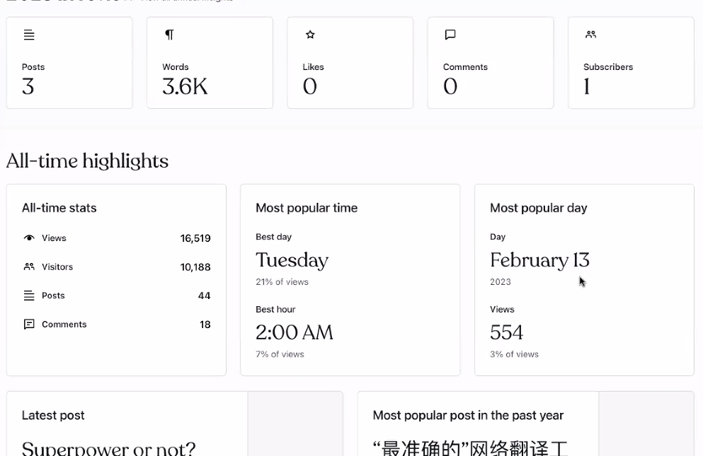  - Social Media will promote website  - Shaoli will set up a meeting with Jessie in April and ask Jessie to work on ATA64 promotion.  - Jessie asks whether we have Slack and Discord for members. Social media will discuss expanding to other channels. | - Fang will add a category under Yifeng Blog.  - Sijin and team will promote CLD websites  - Shaoli will set up a meeting with Jessie in April and ask Jessie to work on ATA64 promotion.  - Liming will work with the social media team and Jessie to talk about expanding chat to Slack and Discord.
6. Social Media | Social Media platforms  - A January planning meeting was hosted and the team developed a plan which has been implemented.  - 2023 Planning  - CLD Social Media Content Bank: posting schedules  - Improve the content type  - LinkedIn Page has grown from 60 to 134 followers since January's meeting  - 2023 Wechat CLD Member Group:  ATA Broadcasting system is broken.  When it is fixed, Shaoli will download the QR code, and update the website page every week.  Will need a social media team to inform members to check email from ATA HQ. | - Shaoli will download the QR code, and update the website page every week once the ATA broadcasting email is sent.
7. ATA64 Proposal | - We have 5.5 hours proposals approved so far.
8. Welcoming message | - Jamie has updated the welcoming message. Tianlu asks LC to review the Welcoming Message and update it. | - Tianlu will email Jamie about updating the welcoming message.
9. Leadership Summit | - Rony gave a summary of the leadership summit.  - ATA HQ is very eager to communicate with divisions and encourage cross-division communications.
10. May 20 ATA Virtual Conference | - What about setting up a watch party  - Rony will set up a Wechat Group and Social Media team will promote the watch party | - Rony will set up a Wechat Group  - Social Media team will promote the watch party
11. Q&A | - Tina’s question: what is CLD’s ultimate goal?  - CLD’s ultimate goal: CLD is a division under ATA, following ATA Division Handbook, with a goal of serving ATA members. Core services include providing a website, listserv, blog and additional educational events.  - In the past two years, we worked beyond our goals to attract new members for ATA, but also to promote other division activities.  - Tina recommends promoting pieces of information from the website on social media. Tina recommends actual business development dicussion.  - Roanna’s comments:  - Whether CLD has resources for interpreters of dialects.  - Roanna would like to be part of a team who needs help with events.  - Jessie mentioned that Slack and discord would be great channels for focused discussions.

Action list:
Action item | Owner(s) | Deadline | Status
Fang will expand current categories. | Fang Sheng
Shaoli will add a tab on the website to include resources for ATA certification exams. | Shaoli |  | Done
Sijin will promote Rony’s previous article on How to Become Certified in 10 hours and another ATA article. | Sijin |  | Done
Rony will reach out to Sijin and Tingting to discuss further details. | Rony | Feb 28th, 2023 | Done
Fang will add a category under Yifeng Blog. | Fang Sheng
Sijin and team will promote CLD websites | Sijin | Feb 3rd, 2023 | Done
Shaoli will set up a meeting with Jessie in April and ask Jessie to work on ATA64 promotion. | Fang Sheng
Liming will work with the social media team and Jessie to talk about expanding chat to Slack and Discord.Liming will host a Social Media Planning meeting. | Liming Pals | Jan 28th, 2023 | Done
Shaoli will download the QR code, and update the website page every week once the ATA broadcasting email is sent. | Shaoli |  | Done
Tianlu will email Jamie about updating the welcoming message. | Tianlu |  | In progress
Rony will set up a Wechat Group | Rony |  | Done
Sijin and Social Media team will promote the watch party | Sijin |  | Done

Next LC meeting: July 26th, 2023 9:00 pm ET - 10:30 pm ET (Second choice: August 2nd, 2023)

