Recorded by: Liming Pals
Date: August 2nd, 2023
Approved by:
Date of Approval:

CLD Leadership Council August 2023 Meeting
Minutes of the Meeting

2023 August Meeting Agenda

Time: 9:00 pm -- 10:30 pm EDT, Wednesday, August 2, 2023
Zoom:
Join Zoom Meeting
https://us06web.zoom.us/j/84571697257
Meeting ID: 845 7169 7257
Passcode: 273405

- Approve minutes from the previous LC meeting 2 min LC
- Update on volunteers 3 min Tianlu

Tianlu Redmon  贾天璐 | Administrator; ATA communication, events team volunteer | tianlu@tianluchinese.com
Liming Pals  王丽明 | Assistant Administrator; ATA communication, social media team leader | limingpals@gmail.com
Shaoli Gu  古韶莉 | Webmaster, website editor | shaoligu@gmail.com
Rony Gao  高嵘 | Events team leader, website editor | rony.gao@gmail.com
Sijin Xian  先思瑾 | Yifeng Editor-in-Chief, Social media team volunteer | projects@xiansijin.com
Fang Sheng  盛方 | Yifeng editor, website editor | shengf@hotmail.com
Jessie Liu  刘子畅 | The CLD Podcast host | jessieliu28@yahoo.com
Tingting Qin  秦婷婷 | Social media team volunteer, events team volunteer | tq@tingbridge.com
Additional volunteers | Social media:  Mingshu Wu Zhang 张吴明姝  Tina Teng 鄧欣亞  Yijia “Sasha” Ding  Website:  Jessie Doherty 祝轶君  Yifeng:  Fang Sheng 盛方  Ben Murphy  Events:  Roanna Cheung 张若荇  Ad hoc:  Zhenhuan “Duoduo” Lei 雷朵朵

Team/Item | Number of Minutes | Speaker
3. ATA64  (ATA63 prep LC meeting minutes for reference)  - Promotion: website, social media, podcast, Yifeng  - Chinese-track sessions  - CLD Dinner  - CLD ambassadors  - ATA64 buttons  - ATA64 WeChat Group  - Annual Members Meeting  - Debriefing CLD Cafe  - Recruiting volunteers | 20 | LC
4. Teams’ update on:
Yifeng | 10 | Fang, Sijin
CLD events | 10 | Rony
The CLD Podcast | 10 | Jessie
Website | 10 | Shaoli
Social media | 10 | Liming
Feedback from attendees | 10 | Attendees
Other matters/agenda proposals & schedule for next LC meeting | 5 | LC

Minutes:

Topic | Summary of discussion | Conclusion
- Approve minutes from the previous LC meeting | - Tianlu made a motion and Shaoli seconded the motion to approve the previous minute.
- Welcome volunteers | - Intro and Welcome Sijin to take the role as Chief Editor for Yifeng
- ATA 64  (ATA63 prep LC meeting minutes for reference)  - Promotion: website, social media, podcast, Yifeng  - Chinese-track sessions  - CLD Dinner  - CLD ambassadors  - ATA64 buttons  - ATA64 WeChat Group  - Annual Members Meeting  - Debriefing CLD Cafe  - Recruiting volunteers | ATA64  - Social media team will take the initiative to start to promote ATA64  - Rony mentioned that we could recommend our members to apply for the scholarship or other rewards which will benefit our members (Deadline was 2023/07/31); will do for future years.  - Liming will research a list of rewards to share with the members.  - Blog post: invitation to local members to write a blog about Miami.  - Call for action: write a blog to motivate people to write blogs for Yifeng.  - Podcast: an episode for ATA64?  - Chinese-track sessions:  - We have many 30-min sessions which may be hard to go deeper on a topic  - We may want to try to invite them to come back to speak  - Rony recommended making a list of ATA64 sessions by CLD members and share via social media first.  - Jessie will be in charge of organizing the CLD Dinner. We encourage more volunteers to help her.  - Shaoli and the team will contact HQ. The point of contact is Kathryn DeVito Kathryn@atanet.org  - TJ Morgan Trenton@atanet.org  - CLD ambassadors: we will have 15 buttons made for CLD ambassadors, please wear the button and return those to Tianlu and Liming afterwards.  - ATA64 buttons: Jessie Doherty will try to design a few samples and share with Shaoli. Shaoli will share all the designs we had in the past years.  - Tianlu will send a website for the Website team to refer for button design.  - Tingting will establish an ATA64 CLD wechat group and post netiquette in the group notice.  - CLD annual membership meeting: we don't know the exact time but we normally host it on Sunday night EST. We encourage all volunteers and LC members to participate in the meeting. We won't have distinguished guests so we may have networking activities.  - CLD annual membership meeting is a good opportunity to recruit volunteers.  - Debriefing CLD Cafe: Rony asks whether we should invite all members to participate in the debriefing CLD Cafe. Tingting thinks it is a good idea to invite those who did not go to the conference. Rony suggests that we should readjust the topics of the debrief. Jessie asks what the goals of the debrief are. Tianlu recommends that we should encourage people to share what they learn but also inspire those who do not go to the annual conference.  - Social media team will put together a list of previous articles including ATA and Smart Habits for Translators podcast. | - Social media team will take the initiative to start to promote  - Liming will research a list of rewards to share with the members.  - Blog post invitation to local members to write a blog about Miami.  - Call for action: write a blog to motivate people to write blogs for Yifeng.  - Rony will put together a list of sessions of all speakers from CLD  - Shaoli and the team will contact HQ.  - Jessie Doherty will try to design a few samples of the CLD Buttons and share with Shaoli.  - Shaoli will share a template and all the designs we had in the past years.  - Tianlu will send a website for the Website team to refer for button design.  - Tingting will establish an ATA64 CLD wechat group and post netiquette in the group notice.  - Social media team will put together a list of previous articles including ATA and Smart Habits for Translators podcast.  - Tianlu will follow up with Jessie about CLD Dinner and an ATA podcast to promote ATA64.
4. Yifeng | - Tianlu shared a video from Fang. Yifeng's work has been impacted by a few events, including the issues that we have with the website.  - Sijin is willing to take the role of editor in chief. Barbara is resigning from the editor's role. Fang is willing to continue to work as an editor.  - Sijin hopes to take some actions to attract more volunteers to write content.  - Sijin hopes that we will have a workflow to be proactive and establish a schedule of content. | - Sijin will create “content bank” for Yifeng to keep track of all communications and workflow  - Sijin will find a local CLD member to write about Miami  - Sijin will brainstorm topics and potential contributors and start outreach
5. Social Media | Social Media platforms  - Continued amazing work by the team:  - 2023 Planning  - CLD Social Media Content Bank: posting schedules  - New update: Tina recommended that we reuse our CLD website.  - Sijin still continues to post twice a week and the social media team repost regularly.  - Encourage LC members to repost and like our post.  - LinkedIn Page has grown to 198 followers since January's meeting  - LinkedIn comment is also a good way to promote the post.  - 2023 Wechat CLD Member Group:  Mingshu feels that everything is going well in the wechat groups.
6. CLD Events | - We had a goal of 8 CLD Cafes  - We have hosted 5 events  - We plan to do another Translation Slam (Chinese to English) and Interpreting slam  - ATA64 Debriefing (October 2023)  - CLD Happy Hour (December 2023)  - Tingting asks that we would need to filter all the ATA sessions and invite the most relevant sessions for CLD members.  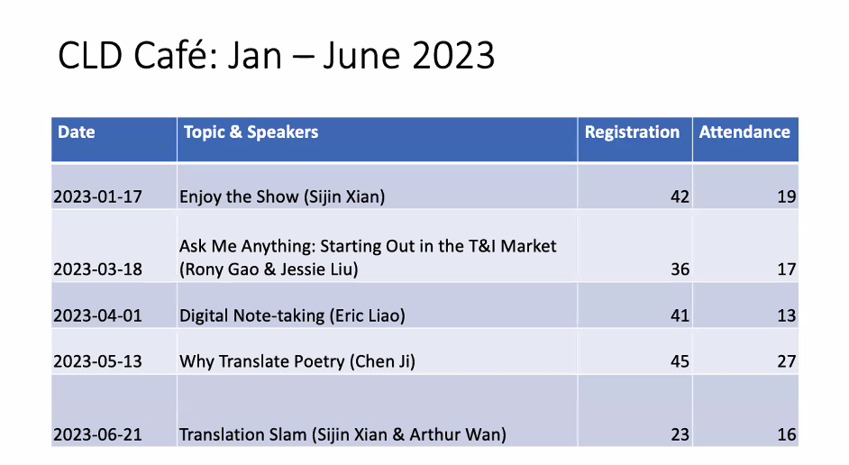
7. Website | - Added the ATA Certification tab thanks to Jessie  - Jessie will provide training to Sijin on how to use Wordpress.  - Sijin asks to change the email address from Sheng Fang to Sijin.  - Tianlu recommends updating LC members and adding the names of our volunteers. | - Website team will add ATA64 related links and CLD events and events pictures to the gallery.  - Website team will add past officers’ and volunteers’ names as well as Sijin’s info to “About Us.”  - Jessie will provide training to Sijin on how to use Wordpress.  - Sijin will change the email address from Sheng Fang to Sijin.  - Sijin will send bio and profile photo to the website team.
8.Next LC Meeting | - A shorter LC meeting to discuss ATA64 related matters on Sept 13th Wednesday 9PM ET | - Tianlu to send calendar invites for 9/13 LC meeting

Action list:
Action item | Owner(s) | Deadline | Status
- Liming will research a list of awards to share with the members.  - Liming will share with Sijin a list of ATA related articles and find a few local CLD members in FL.  - Social media team will put together a list of previous articles including ATA and Smart Habits for  Translators podcast.  - Social media team will take the initiative to start to promoting ATA64 | Liming | August 20th | Rony replied:  Here are two ATA members I found using E-to-C as a filter and Miami's zip code and a 100-mile radius  1) Juliana Yan  https://web.atanet.org/onlinedirectories/tsd_view.php?id=18103  2) Xiaoling Y. Richards  https://web.atanet.org/onlinedirectories/tsd_view.php?id=7338
- Liming will share previous Yifeng articles related to tips to attend the annual conference.  - Google Drive  - Yifeng Original Blogpost 2011-2013 | Liming | August 13th. | Done
- Rony will put together a list of sessions of all speakers from CLD | Rony | August 13th | Done
- Tianlu will send a website for the Website team to refer for button design. | Tianlu | Aug 8, 2023 | Done
- Tianlu will follow up with Jessie about CLD Dinner and an ATA podcast to promote ATA64. | Tianlu | Aug 12 | Done
- Tianlu to send calendar invites for 9/13 LC meeting | Tianlu | August 8 | Done
- Tingting will create an ATA64 CLD wechat group and post netiquette in the group notice. | Tingting |  | Done
- Sijin will write invitations to local members to write a blog about Miami. | Sijin |  | Canceled
- Sijin will send bio and profile photo to website team. | Sijin | August 9 | Done
- Sijin will change the email address from Sheng Fang to Sijin. | Sijin |  | Done
- Call for action: write a blog to motivate people to write blogs for Yifeng. | Sijin | August 2023 | Done
- Shaoli and the team will contact HQ. | Shaoli | August 6th | Done
- Website team will add past officers’ and volunteers’ names as well as Sijin’s info to “About Us.” | Shaoli |  | Sijin’s info is done.
- Website team will add ATA64 related links and CLD events and events pictures to the gallery. | Shaoli | Jan 28th, 2023 | Done
- Jessie Doherty will provide training to Sijin on how to use Wordpress | Jessie Doherty |  | Done
- Shaoli/Jessie Doherty will design a CLD Button. | Shaoli |  | Done
- Sijin will create Yifeng content bank to document workflow and ideas | Sijin | August 4, 2023 | Done
- Sijin will brainstorm topics and ideas for Yifeng and start outreach | Sijin | August 11, 2023 | Done
- Sijin will publish Rony’s list of ATA64 sessions on Yifeng | Sijin | September, 2023 | Canceled-on Website

Next LC meeting: September 13th, 2023 9:00 pm ET - 10:30 pm ET (Second choice: September 20th)

